Article

**Gut microbiota affects aneurysms through biomechanical mechanisms: A mendelian randomization study**

**Supplementary materials**

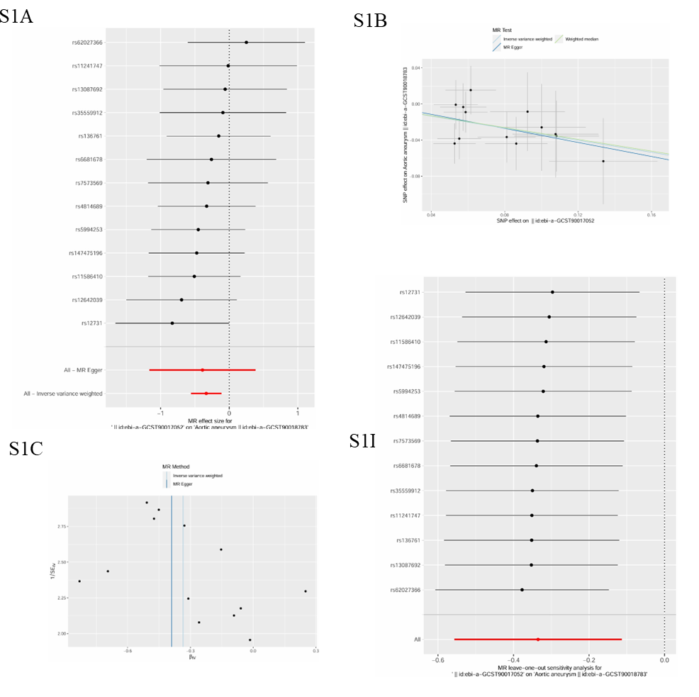

**Figure S1.** Causal relationship between RuminococcaceaeNK4A214 and aortic aneurysms. **(A)** Forest plot of causality between RuminococcaceaeNK4A214 and aortic aneurysms; **(B)** Scatter plot of causality between RuminococcaceaeNK4A214 and aortic aneurysms; **(C)** Funnel plot of causality between RuminococcaceaeNK4A214 and aortic aneurysms; **(D)** “leave-one-out” plot of causality between RuminococcaceaeNK4A214 and aortic aneurysms.

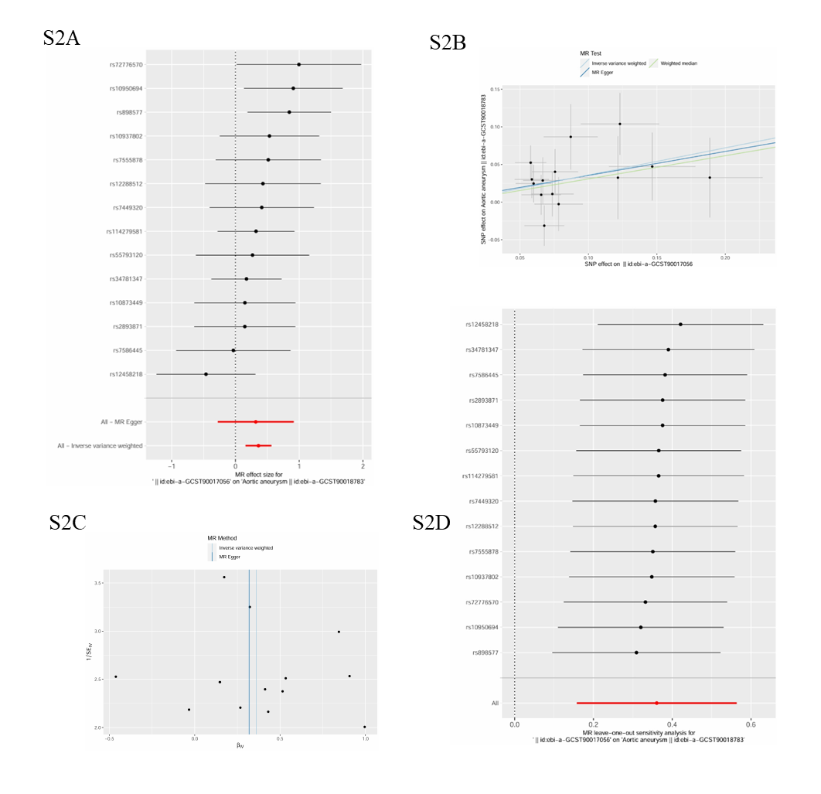

**Figure S2.** Causal relationship between Ruminococcacea eUCG005 and aortic aneurysms. **(A)** Forest plot of causality between Ruminococcacea eUCG005 and aortic aneurysms; **(B)** Scatter plot of causality between Ruminococcacea eUCG005 and aortic aneurysms; **(C)** Funnel plot of causality between Ruminococcacea eUCG005 and aortic aneurysms; **(D)** “leave-one-out” plot of causality between Ruminococcacea eUCG005 and aortic aneurysms.

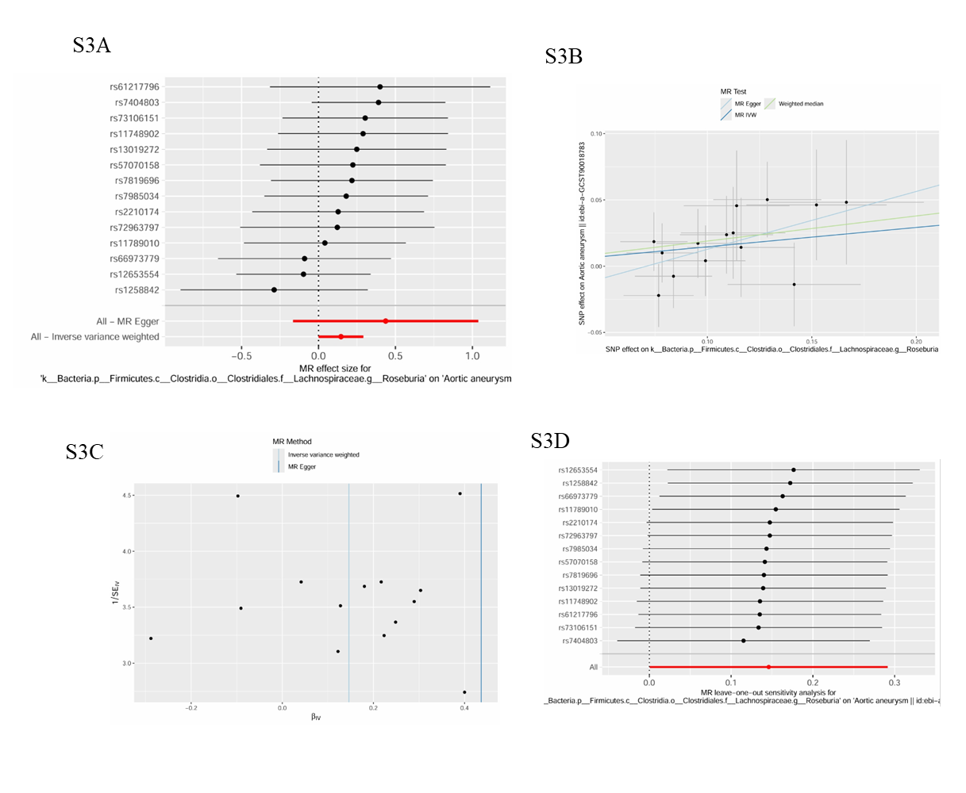

**Figure S3.** Causal relationship between Roseburia and aortic aneurysms. **(A)** Forest plot of causality between Roseburia and aortic aneurysms; **(B)** Scatter plot of causality between Roseburia and aortic aneurysms; **(C)** Funnel plot of causality between Roseburia and aortic aneurysms; **(D)** “leave-one-out” plot of causality between Roseburia and aortic aneurysms.

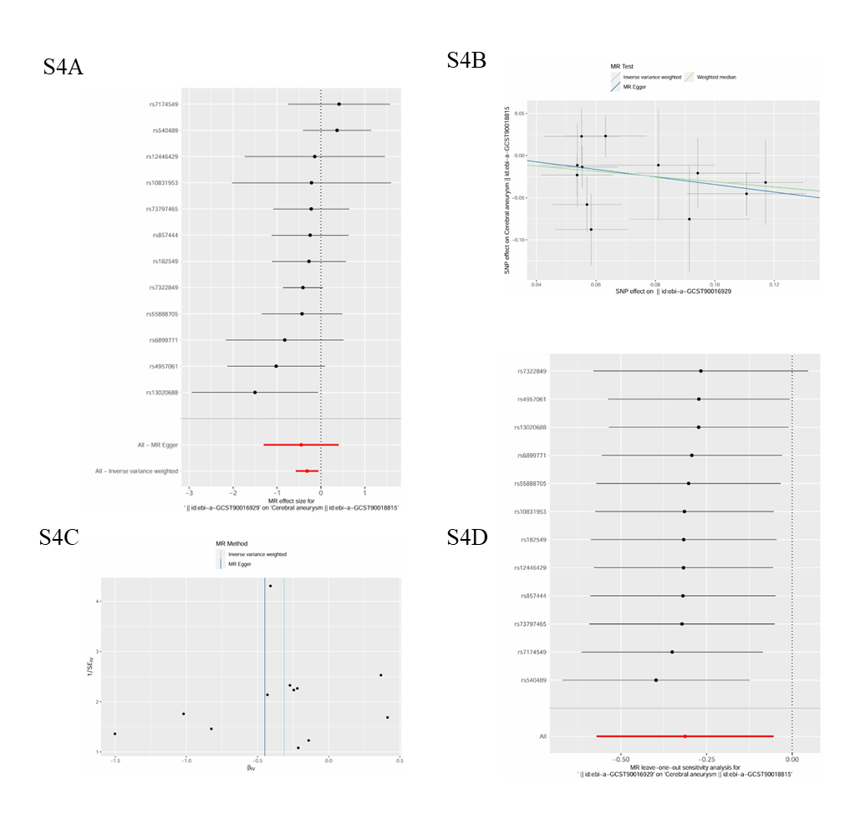

**Figure S4.** Causal relationship between Bifidobacteriales and cerebral aneurysms. **(A)** Forest plot of causality between Bifidobacteriales and cerebral aneurysms; **(B)** Scatter plot of causality between Bifidobacteriales and cerebral aneurysms; **(C)** Funnel plot of causality between Bifidobacteriales and cerebral aneurysms; **(D)** “leave-one-out” plot of causality between Bifidobacteriales and cerebral aneurysms.

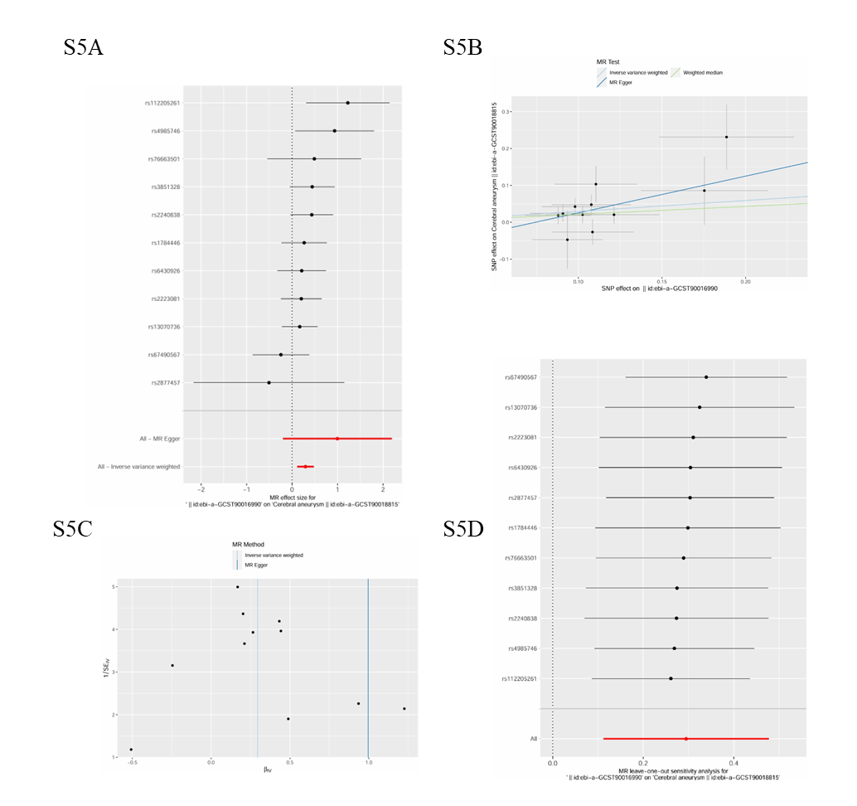

**Figure S5.** Causal relationship between Eggerthella and cerebral aneurysms. **(A)** Forest plot of causality between Eggerthella and cerebral aneurysms; **(B)** Scatter plot of causality between Eggerthella and cerebral aneurysms; **(C)** Funnel plot of causality between Eggerthella and cerebral aneurysms; **(D)** “leave-one-out” plot of causality between Eggerthella and cerebral aneurysms.

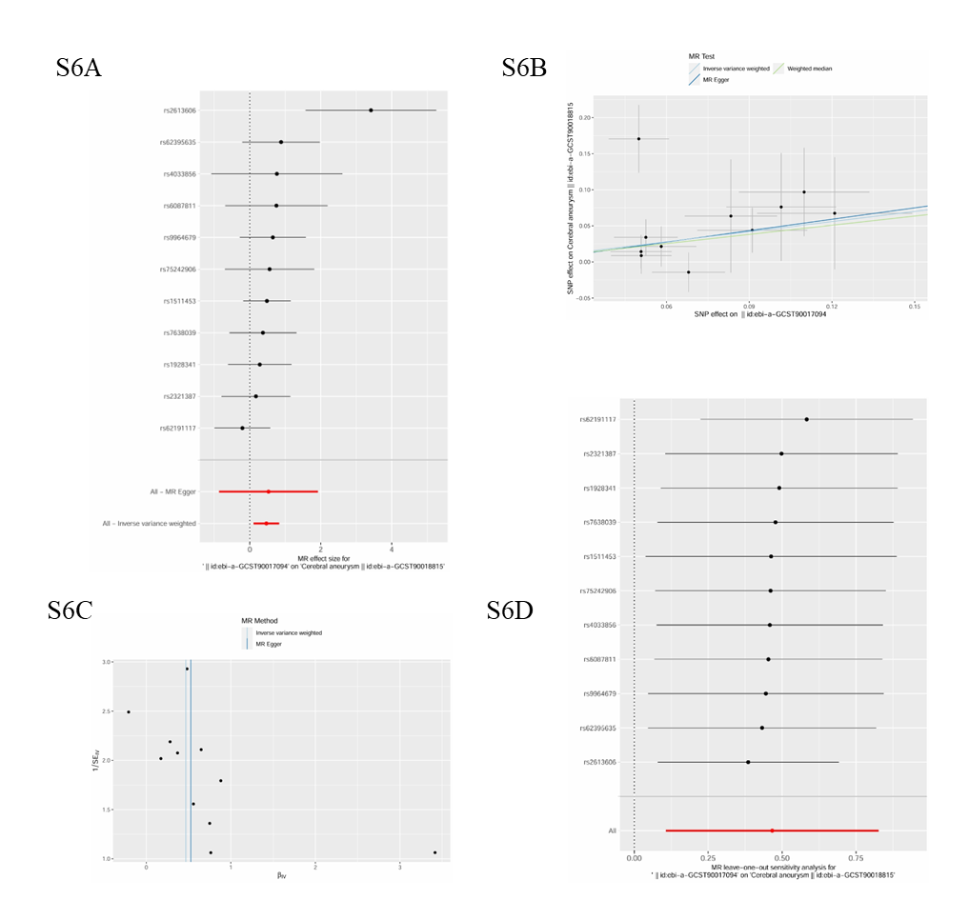

**Figure S6.** Causal relationship between Burkholderiales and cerebral aneurysms. **(A)** Forest plot of causality between Burkholderiales and cerebral aneurysms; **(B)** Scatter plot of causality between Burkholderiales and cerebral aneurysms; **(C)** Funnel plot of causality between Burkholderiales and cerebral aneurysms; **(D)** “leave-one-out” plot of causality between Burkholderiales and cerebral aneurysms.

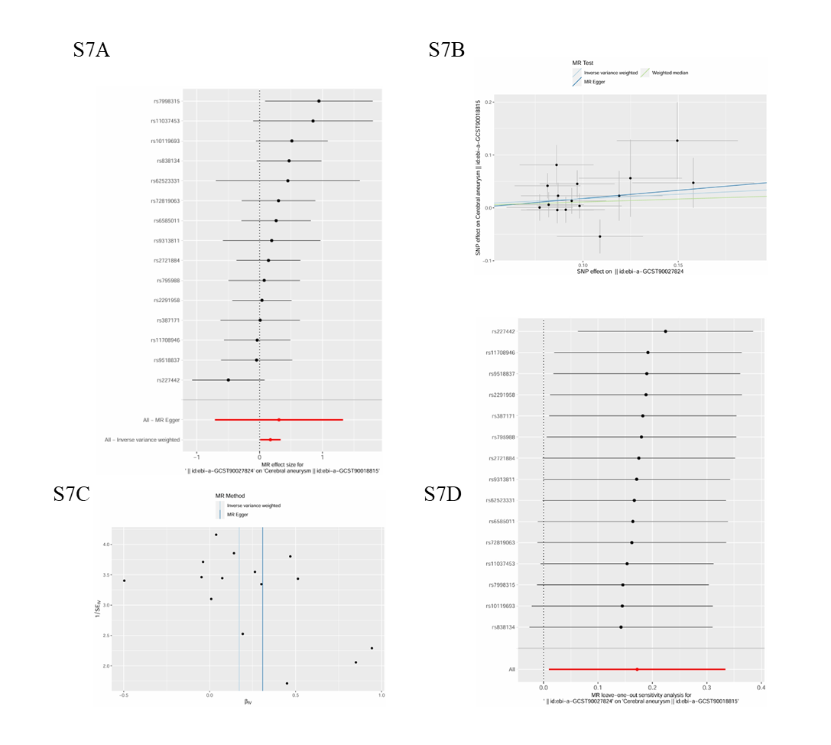

**Figure S7.** Causal relationship between dorei and cerebral aneurysms. **(A)** Forest plot of causality between dorei and cerebral aneurysms; **(B)** Scatter plot of causality between dorei and cerebral aneurysms; **(C)** Funnel plot of causality between dorei and cerebral aneurysms; **(D)** “leave-one-out” plot of causality between dorei and cerebral aneurysms.

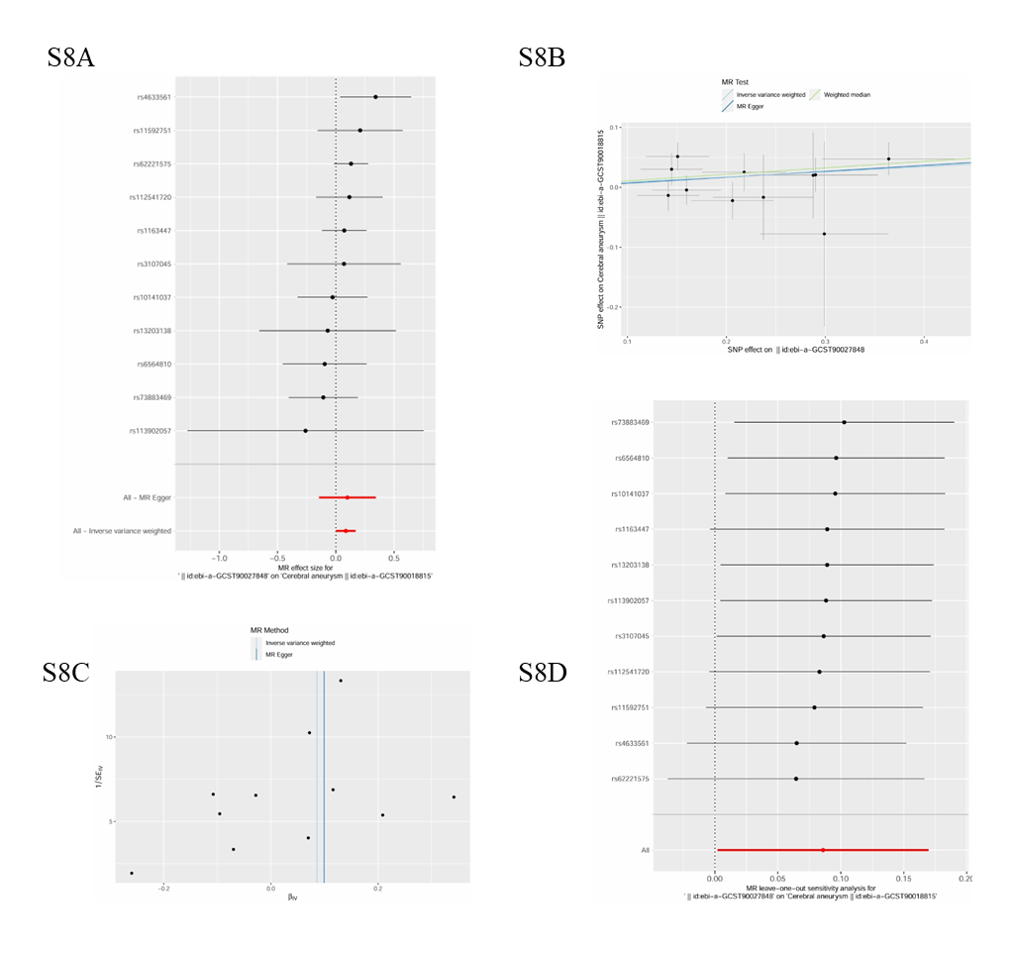

**Figure S8.** Causal relationship between Dorea and cerebral aneurysms. **(A)** Forest plot of causality between Dorea and cerebral aneurysms; **(B)** Scatter plot of causality between Dorea and cerebral aneurysms; **(C)** Funnel plot of causality between Dorea and cerebral aneurysms; **(D)** “leave-one-out” plot of causality between Dorea and cerebral aneurysms.