Article

**A biomechanics research on drug therapy in the rehabilitation of sports training injuries**

**Lulu Yang1, Yu Dong2,\***

1 Sports College, Shanxi Vocational University of Engineering Science and Technology, Taiyuan 030619, China

2 Basic department, Wuhan Donghu University, Wuhan 430212, China

**\*****Corresponding author:**Yu Dong, 15645650526@163.com

**Abstract:** In the process of sports training and competition, if sports injury occurs, it not only has a serious impact on the physical and psychological of athletes, but also has a negative impact on the overall training and competition. During the competition, if effective treatment is not obtained, it can have an irreversible impact on athletes’ future participation in sports. Nowadays, many athletes lack knowledge on the prevention and treatment of sports injuries during physical exercise. Therefore, it is urgent to conduct research and analysis on the treatment methods for training injury rehabilitation. In this paper, the visual analogue scale (VAS) and cell landscape analysis technology were used to analyze and compare the therapeutic effects of platelet rich plasma (PRP) injection technology, diclofenac, indomethacin, Qili San and placebo tablets. Focusing on how these drugs promote rehabilitation by affecting mechanical parameters and tissue mechanical properties, it is concluded that PRP injection technique, diclofenac and indomethacin improve the treatment effect of pain after rehabilitation of sports injuries. The number of people who completely recovered with Indomethacin was 4 and that with placebo was 2. The results show that these drugs significantly improve the mechanical properties of the tissue and contribute to the rehabilitation process. This study has further explored the drug treatment of sports injury, explored several drug treatment mechanisms and efficacy and has guiding significance for subsequent drug treatment of sports injury.

**CITATION**

Yang L, Dong Y. A biomechanics research on drug therapy in the rehabilitation of sports training injuries. Molecular & Cellular Biomechanics. 2024; 21(1): 215. https://doi.org/10.62617/mcb.v21i1.215

**ARTICLE INFO**

Received: 25 June 2024

Accepted: 17 July 2024

Available online: 24 September 2024

**COPYRIGHT**



Copyright © 2024 by author(s).

*Molecular & Cellular Biomechanics* is published by Sin-Chn Scientific Press Pte. Ltd. This work is licensed under the Creative Commons Attribution (CC BY) license.

https://creativecommons.org/licenses/by/4.0/

**Keywords:** athletic training; sports injury; drug therapy; vas simulation scoring technique; cytoscape analysis technique

**1. Introduction**

As the science and technology develop rapidly, the advanced working methods used by modern people are also increasingly replacing the traditional manual working methods. Although this method makes people more convenient, it also makes the muscles of the human body unable to get good training, which is likely to cause harm to the body during sports activities. Sports injury is an injury to body function in sports activities. It easily occurs in fitness activities, sports courses and other exercise activities. It has always been an important problem in physical exercise. Its causes are closely related to the form, intensity, skills and environment of fitness exercises. It can damage the motor system of the human body, as well as the blood vessels and nervous system of the body. In the rehabilitation of sports training injuries, drug treatment is an important part. Combining traditional training with physical rehabilitation support methods can effectively reduce pain and restore injured muscles and bones. In addition, drug therapy not only works by relieving pain and inflammation, but also promotes tissue repair by affecting mechanical parameters and tissue mechanical properties. However, the effectiveness of different drugs varies greatly and existing drug therapy research is only based on the description of treatment phenomena, lacking exploration of treatment mechanisms and effects. Therefore, the corresponding research and assessment of the mechanism and influence of different drugs on the rehabilitation treatment of sports injury has important guiding significance for the improvement of sports training injury rehabilitation and its future development.

The modern rehabilitation protocol emphasizes team cooperation and appropriate rehabilitation plan. The rehabilitation team must be led by a trained sports physiotherapist, who should clearly understand the protocols and interventions required at different stages. The rehabilitation program for injuries and illnesses is being implemented worldwide, but it needs to be introduced based on the nature of the exercise and the available facilities. Keith Goddard considered that the key factors of a successful sports injury rehabilitation program were the application of modern rehabilitation programs, appropriate and timely surgical intervention and the wise use of drugs as needed under appropriate supervision [1]. Gennarelli Sonora M believed that there was a relationship between psychological factors and the recovery of musculoskeletal sports injury and conducted a systematic evaluation according to the preferred reporting items of the systematic evaluation and meta-analysis guidelines. Interventions such as relaxation/guidance imagery, positive self dialogue, goal setting, counseling, emotional/written disclosure and modeling videos were found to be effective interventions to promote the recovery of musculoskeletal sports injury. These interventions promoted positive emotional changes, pain management, exercise compliance and rehabilitation compliance [2]. Xu Shidong assessed the degree of muscle fatigue during the training period after surgery and penetrated the neuromuscular training method in time and stages in the whole rehabilitation path management to alleviate mild muscle fatigue in time and promote the continuous recovery of proprioception. The experimental results showed that the preoperative position deviation of the two groups of patients was basically the same and there was no significant difference in the average deviation of the injured knee joint angle. The key factor of all sports injury rehabilitation programs was injury prevention. Athletes and their coaches should understand the injury and subsequent problems [3]. Modern rehabilitation emphasizes teamwork and proper planning, involving proper supervision, surgical intervention, drug use, psychological intervention, etc., which can promote the recovery of musculoskeletal sports injury.

Appropriate comprehensive intervention measures such as exercise training and physical therapy can help athletes or ordinary patients recover from skeletal muscle sports injury. This job requires a complete rehabilitation plan and teamwork. However, psychological intervention alone is not enough. Drug therapy is a common and effective medical treatment method that can prevent, treat and control diseases through the use of various drugs. Malmgaard-ClausenMD reckoned that the clinical symptoms of early tendinopathy improved with physical recovery, but this improvement did not increase with the increase of nonsteroidal anti-inflammatory drug treatment. Compared with patients with longer duration of symptoms, patients with shorter duration of symptoms had greater clinical improvement after undergoing physical rehabilitation plans [4]. Wiffen Philip J considered that oral nonsteroidal anti-inflammatory drug were not a good choice and the incidence of gastrointestinal side effects of such drugs was high. He evaluated the efficacy and safety of Diclofenac patch applied directly to the pain injury site in the treatment of acute mild sports injury pain. The advantages of this new therapy included its ease of use and lack of systemic side effects [5]. Mohammad Nadir Haider believed that motor intolerance after concussion was considered to be the result of autonomic nervous system dysfunction. The evidence that subthreshold aerobic exercise normalized cerebral vascular physiological dysfunction was proposed and it was the “drug” for patients with symptoms after concussion and persistent concussion [6]. Mariana Sanchez Diaz proposed that flavonoid polyphenols treatment could increase muscle strength by 7.14%, reduce muscle soreness by 4.12% and restore creatine kinase concentration without change. In the rehabilitation of sports injury, drug treatment could reduce pain, inflammation and swelling, thereby helping patients recover faster [7]. The application effects of PRP(Platelet Rich Plasma) injection technology, diclofenac sodium, indomethacin and Qili San in the rehabilitation of sports injuries have been discussed in detail. Gentile, Pietro et al. reviewed the mechanism of PRP and pointed out that PRP promotes tissue repair by releasing growth factors [8]. Huang, Hetao et al. reviewed the effect of diclofenac sodium in the treatment of pain, showing its significant anti-inflammatory and analgesic effects, but it has gastrointestinal and cardiovascular risks, and its long-term safety needs attention [9]. Fogel, Evan et al. studied the analgesic and anti-inflammatory effects of indomethacin after exercise, which is effective but has obvious side effects, limiting its application [10]. Based on this innovation, this study first comprehensively compared the effectiveness and safety of PRP injection technology, diclofenac sodium, indomethacin and Qili San in rehabilitation of exercise-induced knee injury, providing a comprehensive evaluation of efficacy. Secondly, multivariate regression analysis is used to control confounding variables to ensure the accuracy and reliability of the results and enhance the scientific nature of the study. In addition, the reported effect size and 95% confidence interval increase the interpretative and clinical significance of the results, and provide comprehensive guidance for clinical practice by discussing in detail the side effects of each treatment and its prevention and management. The research on drug treatment of sports injury has attracted extensive attention and exploration in the world. The goal of these studies is to provide more effective and safe treatment methods to promote the rehabilitation and recovery of sports injury. With the continuous progress of science and technology, more breakthroughs and innovations in sports injury drug treatment can be expected in the future, which can bring better therapeutic effects to sports injury patients.

Whether athletes participate in sports training or competition, it is difficult to effectively avoid sports injury, which can not only affect the competition or training, but also have a huge negative impact on the career of athletes. This is a problem that every athlete should pay attention to. With the development of economy, mass sports are becoming more and more popular and developing faster and the probability of sports injury is also increasing. Rehabilitation treatment is particularly important. It can not only promote the rapid recovery of sports injury, reduce pain, but also enable patients to return to work as soon as possible, making contributions to social construction. Based on VAS(Visual Analogue Scale) pain visual simulation scoring technology and Cytoscape analysis technology, this paper further studies the therapeutic effects of PRP injection technology, Diclofenac, Indometacin and Qili San on sports injury, thereby helping people who need rehabilitation treatment for sports injury understand more and better treatment methods to quickly recover to normal living conditions

**2. Rehabilitation effect of PRP injection technology combined with rehabilitation training on sports induced knee joint injury**

**2.1. Biological characteristics of PRP**

PRP is a method of centrifuging human peripheral blood to obtain platelet concentrate. When activated, PRP can release a variety of growth factors, thus playing a positive role in the repair and regeneration of body tissues and cells. The growth factors in PRP can promote cell proliferation and angiogenesis, and enhance the elasticity and strength of the tissue. Through local injection of PRP, it is possible to increase the repair speed and regeneration ability of damaged tissues, improve joint range of motion and muscle strength, and thus achieve faster recovery. In addition, PRP injections also help relieve pain and accelerate tissue healing by increasing local blood flow and reducing inflammation. Therefore, PRP has been extensively applied in the cure of sports injury, muscle, bone and other diseases. There are approximately 800 protein molecules in platelets and through different chemical methods, approximately 1500 protein molecules can be synthesized. After inflammation or injury, there are a large number of bioactive factors in the body, such as platelet-derived growth factor, vascular endothelial growth factor, epidermal growth factor, basic fibroblast growth factor, hepatocyte growth factor, insulin-like growth factor and others [11,12].

**2.2. Experimental data collection**



**Figure 1.** Experimental technology route.

This project conducts experiments on PRP. Its innovation is the use of one of the most commonly used composite therapies internationally, combined with plasma platelet perfusion and rehabilitation exercise. The following is the experimental technology roadmap, as shown in **Figure 1**.

Experimental group: 20 patients received intravenous injection of PRP and cooperated with recovery exercise one time every two weeks for a total of 4 cycles. Under disinfection, 40 mL of PRP was extracted from the patient’s own elbow vein blood and prepared using the NGL-XCF3000 blood drug separator from Sichuan Nigale Company. According to the standard preparation process, 7.5 mL of PRP was prepared and injected into the patient’s knee. After each injection, local pressure for 3 min was immediately applied to avoid bleeding. After each injection, the patient’s knee needed to be bent and extended 10 times to make the distribution of PRP more balanced. In terms of rehabilitation training, it was mainly carried out through stretching training, muscle strength training, NJF (Neuromuscular Joint Facilitation) training and physical therapy. The traction exercise focused on traction of the patient’s triceps femoris, with each traction lasting for 3 min and once a day. A 10 minute muscle strength exercise was performed every day. The exercise method of NJF was based on the knee bending inner leg rotation activity mode and knee stretching outer leg rotation activity mode in NJF, conducted 4 times a day with an interval of 6 min between each exercise. In the case of weight loss, the coordination training of the muscles around the knee joint, weight bearing training of the affected lower limb, orthostatic balance training, walking training and others were all sports treatment items that needed to be carried out one time a day and 30 min per day. The recovery time for the above projects was 3 days per week, totaling 8 weeks.

Control group: 20 subjects received physical factors such as microwave, ultrasound, infrared polarization, magnetic vibration hyperthermia, etc. Physical therapy was performed five times a week for a total of eight weeks. The processing of each physical factor took 5 min and two or more physical factors were not allowed to be processed simultaneously. Recovery exercises after surgery was performed. The method of recovery period was the same as that of the experimental group.

**2.3. Efficacy evaluation indicators**

The pain VAS, knee joint WOMAC (Western Ontario and McMaster University) score and knee joint plasticity evaluation methods were used to evaluate the knee joint pain, flexion plasticity and knee joint mobility of the two groups of patients before and 8 weeks after treatment [13].

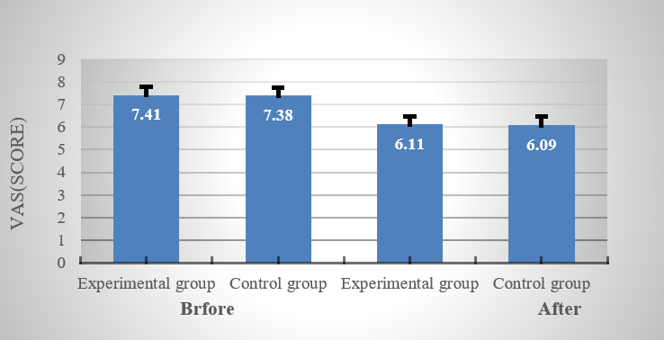

**Figure 2.** Comparison of two sets of VAS (point).

Software was used to summarize and analyze various data related to clinical treatment of two groups of patients with sports induced knee joint injury. Statistical tests were conducted on *P* and *T* values. The comparison of VAS data before and after treatment of the experimental group and the control group is depicted in **Figure 2** and **Table 1**.

**Table 1.** Comparison of VAS in different control groups.

|  |  |  |  |  |  |  |
| --- | --- | --- | --- | --- | --- | --- |
| **Time** | **Group** | **Example** | **Mean** | **Deviation** | ***T* value** | ***P* value** |
| Before | Experimental group | 20 | 7.41 | 1.03 | 0.251 | 0.801 |
| Control group | 20 | 7.38 | 1.00 |
| After | Experimental group | 20 | 6.11 | 1.04 | −3.785 | <0.001 |
| Control group | 20 | 6.09 | 0.83 |

As shown in the above chart, the *T* values before and after treatment were 0.251 and −3.785, respectively. The *P* value was 0.801 before treatment and less than 0.01 after treatment. There was no significant difference in VAS scores between the experimental group and the control group. After 8 weeks of treatment, both of them showed a decrease in VAS scores, indicating an improvement in all clinical manifestations. Both groups underwent separate t-tests after 8 weeks. Comparing the VAS scores of the two groups before and after treatment, it can be seen that the score improvement of the experimental group was better than that of the control group. Therefore, the treatment effect of the experimental group was better than that of the control group.

The treatment results and analysis of PRP combined with rehabilitation training on knee joint mobility are shown in **Figure 3** and **Table 2**.

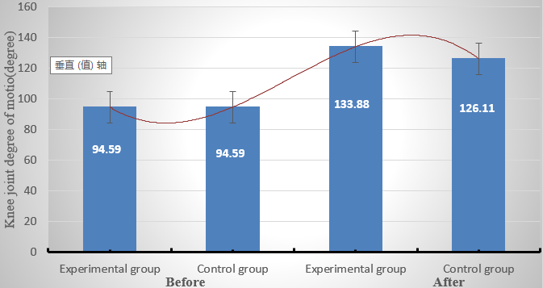

**Figure 3.** Comparison of knee joint mobility between two groups (degrees).

**Table 2.** Comparison of knee joint mobility between different groups.

|  |  |  |  |  |  |  |  |
| --- | --- | --- | --- | --- | --- | --- | --- |
| **Time** | **Group** | **Example** | **Activity Mean（Degree）** | **Deviation** | ***T* value** | ***P* value** | **Cohen’s d** |
| Before | Experimental group | 20 | 94.59 | 17.13 | 0.396 | 0.254 | - |
| Control group | 20 | 94.59 | 13.82 |
| After | Experimental group | 20 | 133.88 | 6.01 | −3.814 | <0.001 | 1.05 |
| Control group | 20 | 126.11 | 9.19 |

Seen from **Table 2**, the *T* values of the two groups before and after treatment were 0.396 and −3.814. The *P* value before treatment was 0.254, indicating that there was no significant difference or statistically significant difference between the two groups before treatment. After 8 weeks of observation, a comparison was made between the two groups of patients on postoperative joint movement. It was found that both groups of patients had improved joint movement after surgery, indicating a significant improvement in joint movement after surgery. After the 8 weeks treatment course, a separate T test was conducted, with a value *P* < 0.01, indicating a statistically significant difference between the two groups. The effect size not only reflects statistical significance but also provides an assessment of the actual clinical significance of the results. The effect size Cohen’s d was 1.05, which means that the treatment effect between the experimental and control groups was also clinically significant. According to the comparison between the two groups, the score improvement of the experimental group was better than that of the control group and the treatment effect of the experimental group was better than that of the control group. In addition, 95% confidence intervals for differences in knee motion between the experimental and control groups after treatment ranged from 4.45 to 11.77 degrees, showing the estimated range and uncertainty of the effect.

According to the comparative analysis of VAS scores, patients in both treatment groups showed varying degrees of pain relief, while the efficacy of the experimental group was more significant. When the tension of the knee muscles compresses the surrounding capillaries, it can cause abnormal blood circulation, leading to pain symptoms in the knee. Rehabilitation training is needed to alleviate this. The role of physical factors is achieved by promoting local blood circulation and clearing factors that cause knee pain. PRP is a medication with analgesic effects and its main components are various active factors. These three methods all have a significant relieving effect on knee pain. The effect of rehabilitation exercise is similar to that of physical factors for pain relief, both of which aim to alleviate pain by promoting blood circulation. There is a significant difference in the analgesic mechanism between PRP and rehabilitation exercise. Both have a dual effect of promoting blood flow and clearing pain causing factors in the process of promoting blood flow and clearing pain causing factors, but their mechanism is still unclear [14].

PRP injection technique combined with rehabilitation training is clinically significant in the following ways: first, the treatment significantly improves knee mobility, relieves patients’ pain and discomfort, helps to quickly restore motor function and improves quality of life. Second, the method reduces the risk of injury recurrence and reduces long-term medical expenses and time costs. Patients see significant results in the short term, increasing treatment compliance and satisfaction and ensuring better long-term rehabilitation. These clinical values make the PRP injection technique combined with rehabilitation training an effective option for the rehabilitation of athletic knee injuries.

Possible side effects of the PRP injection technique include infection, pain and swelling at the injection site, and rare allergic reactions. Ways to prevent these side effects include strictly following aseptic procedures, using disinfection equipment and disposable syringes to reduce the risk of infection; The injection is administered by a medical professional, using the correct injection technique to minimize pain and swelling at the injection site; An allergy test is performed before a PRP injection to ensure that the patient is not allergic to the injected ingredients.

**3. Therapeutic effect of local diclofenac on mild sports injury pain**

Diclofenac, as a non-steroidal anti-inflammatory drug, reduces pain and inflammation by changing the mechanical properties of tissues. Specifically, diclofenac can reduce the stress and tensile strength of tissues and reduce tissue stiffness and stiffness caused by inflammation. In addition, diclofenac can also relieve pain and swelling by inhibiting the synthesis of prostaglandins and reducing the release of inflammatory mediators. By inhibiting COX-1(Cyclooxygenase 1) and COX-2(Cyclooxygenase 2), diclofenac sodium reduces the production of prostaglandin E2 (PGE2), which reduces the inflammatory response and sense of pain.

**3.1. Experimental data collection**

213 patients with varying degrees of injury were selected and the study subjects were aged between 18 and 78. They were randomly divided into two groups, with one group using Diclofenac and the other group using placebo tablets. The selected research subjects were 148 males and 65 females. In all demography parameters, there was no significant statistical difference between the Diclofenac and placebo groups (as seen in **Table 3**).

**Table 3.** Demographics data and patient characteristics.

|  |  |  |  |  |
| --- | --- | --- | --- | --- |
| **Variable** | **Diclofenac** [**Sodium**](https://baike.sogou.com/lemma/ShowInnerLink.htm?lemmaId=48045&ss_c=ssc.citiao.link) **(*N* = 107)** | **Placebo (*N* = 106)** | **Total (***N* **= 213)** | ***P* Values** |
| Age (Years), mean | 31.11 | 29.88 | 30.49 | 0.441 |
| Standard deviation | 11.82 | 9.92 | 10.89 |  |
| Range | 17.0–77.0 | 17.0–61.0 | 17.0–77.0 |  |
| Gender | 0.190 | | | |
| Male | 79 | 69 | 148 |  |
| Female | 28 | 37 | 65 |
| Location of injury |  |  |  | 0.2500 |
| Foot | 10 | 4 | 14 |  |
| Ankle | 20 | 30 | 50 |  |
| Calf | 8 | 5 | 13 |  |
| Knee | 8 | 12 | 20 |  |
| Thigh | 7 | 6 | 13 |  |
| Finger | 9 | 4 | 13 |  |
| Hand | 7 | 7 | 14 |  |
| Wrist | 7 | 7 | 14 |  |
| Forearm | 9 | 8 | 17 |  |
| Elbow | 7 | 6 | 13 |  |
| Groin | 6 | 9 | 15 |  |
| Other | 9 | 8 | 17 |  |
| Diagnosis |  | | | 0.5594 |
| Sprain | 17 | 18 | 35 |  |
| Sirain | 19 | 16 | 35 |  |

**Table 3.** (*Continued*).

|  |  |  |  |  |
| --- | --- | --- | --- | --- |
| **Variable** | **Diclofenac** [**Sodium**](https://baike.sogou.com/lemma/ShowInnerLink.htm?lemmaId=48045&ss_c=ssc.citiao.link) **(*N* = 107)** | **Placebo (*N* = 106)** | **Total (***N* **= 213)** | ***P* Values** |
| Contusion | 16 | 19 | 35 |  |
| Sprain/Strain | 19 | 20 | 39 |  |
| Sprain/Contusion | 20 | 18 | 38 |  |
| Strain/Contusion | 11 | 13 | 24 |  |
| Other | 5 | 2 | 7 |  |
| Aseline VAS, mean | 6.38 | 6.41 | 6.40 | 0.740 |
| Standard deviation | 1.06 | 1.11 | 1.08 |  |
| Range | 3.8–8.7 | 3.5–9.4 | 3.5–9.4 |  |
| Baseline on pressure, mean | 5.58 | 5.80 | 5.71 | 0.636 |
| Standard deviation | 3.60 | 3.31 | 3.50 |  |
| Range | −13.0–12.1 | −2.1–14.2 | −13.0–13.0 |  |

To assess the efficacy of diclofenac sodium and placebo in the treatment of acute sports injury pain, the study introduced multivariate regression analysis to control for potentially confounding variables. Specifically, a more accurate assessment of treatment efficacy was ensured by introducing age, gender, and baseline health status as covariates.

**3.2. Data dissection**

**Figure 4** shows the difference of VAS daily pain scores between Diclofenac tablets and placebo tablets.

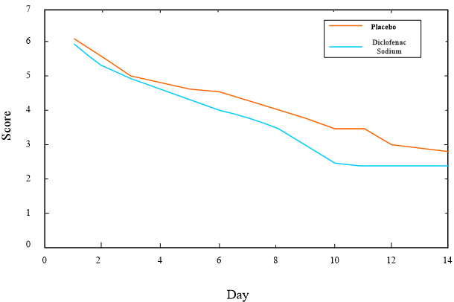

**Figure 4.** VAS daily pain scores of Diclofenac tablets and placebo tablets.

To further verify the therapeutic effect of diclofenac sodium on pain, analysis of variance (ANOVA) was used to compare the VAS scores between the diclofenac sodium group and the placebo group. Concluded from **Figure 4**, after the experiment, both groups of patients showed significant analgesic effects. However, the daily pain perception score of VAS using Diclofenac tablets was always lower than that of VAS using placebo tablets, indicating that the effect of Diclofenac tablets was better than that of placebo tablets. ANOVA analysis showed significant differences in VAS scores after diclofenac sodium treatment among patients of different age groups and genders (*p* < 0.01). Specifically, younger patients (18–35 years old) had significantly better pain relief after diclofenac sodium than older patients (36–78 years old). In addition, male patients had significantly better outcomes than female patients.

Possible side effects of diclofenac include gastrointestinal problems (such as stomach pain, nausea, vomiting, stomach ulcers, and bleeding), impaired kidney function, and increased risk of cardiovascular events. To prevent these side effects, patients are advised to take diclofenac sodium with meals to reduce gastrointestinal irritation, in combination with gastric mucosal protection medications (such as proton pump inhibitors) to reduce the risk of gastric ulcers, and to have regular renal and cardiovascular tests to detect and manage adverse reactions in a timely manner.

**3.3. Multivariate regression analysis**

In this study, multivariate regression analysis was used to assess the therapeutic effect of diclofenac sodium in order to control the effect of confounding variables on the results. The form of the regression model was as follows:

|  |  |
| --- | --- |
| $${VAS}_{post}=β_{0}+β_{1}Treatment+β_{2}Age+β_{3}Gende +β_{4}Baseline VAS+ϵ$$ | (1) |

where ${VAS}_{post}$ is the post-treatment VAS score, Treatment is the treatment group variable (diclofenac sodium = 1, placebo = 0), Baseline VA is the baseline VAS score, and *ϵ* is the error term. The results of the analysis are shown in **Table 4**:

**Table 4.** Results of multivariate regression analysis.

|  |  |  |  |  |
| --- | --- | --- | --- | --- |
| **Variable** | **Coefficient** | **Standard Error** | ***t*-value** | ***P*-value** |
| Intercept | 2.45 | 1.23 | 1.99 | 0.048 |
| Treatment (Diclofenac) | −1.27 | 0.45 | −2.82 | 0.005 |
| Age | 0.02 | 0.01 | 2.14 | 0.033 |
| Gender (Male) | −0.34 | 0.22 | −1.55 | 0.124 |
| Baseline VAS | 0.65 | 0.07 | 9.29 | <0.001 |

As can be seen from the table, the VAS scores of the diclofenac sodium treatment group were significantly lower than those of the placebo group (*p* = 0.005), which suggests that diclofenac sodium has a better effect than placebo in relieving pain in acute sports injuries. Also, age and baseline VAS scores had a significant effect on post-treatment VAS scores (*p* < 0.05), but the effect of gender was not significant (*p* > 0.05).

The introduction of multivariate regression analysis, which controlled for confounding variables such as age, gender, and baseline health status, made the study results more reliable. This analytic approach enhanced the credibility of the findings and provided a solid foundation for subsequent studies.

**4. Therapeutic effect of indometacin on soft tissue sports injury**

65 subjects were selected, including 58 males and 7 females, aging from 16 to 34 years (average age of 22 years). The summary of the sports projects represented is shown in **Figure 5**.

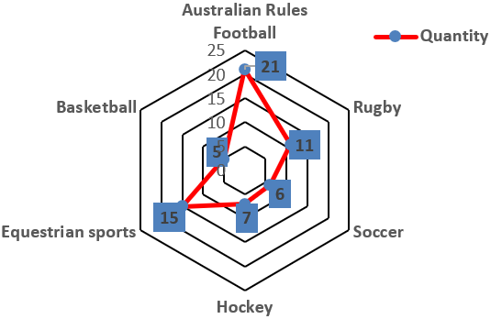

**Figure 5.** Representative motion.

For the final screening, patients needed to arrive at the outpatient clinic within 5 working days of the week, lasting for 5 working days. This allowed for analysis of the response to treatment within one week on the 5th day. Due to work reasons, 9 of the study subjects were excluded from continuous treatment. The remaining 56 patients were split into two groups of 28 each, using Indometacin and placebo respectively.

**Table 5.** Assessment of recovery situation and number of people.

|  |  |  |  |  |
| --- | --- | --- | --- | --- |
|  |  | **Recovery** | |  |
| **Treatment** | **Complete** | **Marked** | **Moderate** | **Slight** |
| Indomethacin (*N* = 28) | 4 | 15 | 8 | 1 |
| Placebo (*N* = 28) | 2 | 10 | 14 | 2 |

**Table 5** summarizes the final evaluation of recovery rates. It can be seen that the number of people who completely recovered with Indometacin (4) was more than that with placebo (2).

**Figure 6** shows the improvement of treatment effectiveness in 56 patients within a week, with the horizontal axis representing time and the vertical axis representing the average improvement effect.

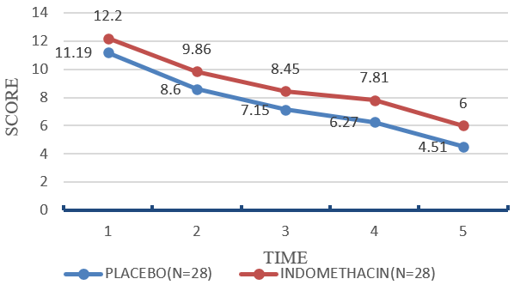

**Figure 6.** Daily improvement during treatment.

In the evaluation of one week of treatment, the Indometacin group had slight advantages over the placebo group and Indometacin showed significantly enhanced efficacy in alleviating pain and swelling. In addition, the side effects of Indometacin are very small, indicating its high safety [15]. In a word, Indometacin may have a certain effect on the treatment of acute soft tissue sports injury, especially in alleviating pain and swelling. However, owing to the relatively small sample size, more large-scale studies are still required to further validate this result.

Indomethacin has significant mechanical effects in reducing soft tissue pain and swelling. By inhibiting the activity of cyclooxygenase (COX) enzyme, indomethacin can reduce the production of inflammatory mediators, thereby reducing tissue stress and inflammatory response. In addition, indomethacin can also improve the elasticity and recovery speed of tissues and improve the mechanical properties of damaged tissues. Clinical data showed good results in terms of pain relief and swelling resolution in patients treated with indomethacin, further validating its role in the rehabilitation of sports injuries.

Possible side effects of indometacin include gastrointestinal problems (such as stomach pain, stomach ulcers, and bleeding), central nervous system effects (such as headaches, vertigo, drowsiness, and depression), and impaired kidney function. Ways to prevent these side effects include instructing patients to take indomethacin at the prescribed dose and not arbitrarily increasing the dose; Combined with gastric mucosal protection drugs to reduce gastrointestinal adverse reactions; Check renal function regularly and monitor central nervous system symptoms, and adjust medication regimen in time.

**5. Therapeutic effect of Qili san on acute sports injury rehabilitation**

**5.1. Introduction to the ingredients and functions of Qili San**

Qili San is a mixture that includes ingredients such as dragon’s blood, frankincense, myrrh, agarwood, safflower, catechu, cinnabar, artificial musk, borneol and cinnabar. The main function of Qili San is to promote blood circulation, remove blood stasis, dispel wind and relieve pain. It can promote blood circulation, dissipate stasis, relieve pain, relax muscles and activate collaterals. Therefore, this article studies the efficacy of Qili San in treating rheumatic pain, traumatic injuries, dysmenorrhea, amenorrhea and other diseases [16,17]. As a traditional Chinese medicine, Qili powder improves tissue mechanical properties by promoting blood circulation and eliminating blood stasis. In terms of promoting blood circulation, the active ingredients in Qi Li Powder can dilate blood vessels and increase local blood flow, thereby accelerating the repair and regeneration of damaged tissues. In addition, Qili powder can also eliminate blood stasis, reduce local swelling and pain, and improve the elasticity and strength of the tissue. Studies have shown significant improvements in tissue repair speed and strength in patients using seven Centile powder, demonstrating its effectiveness and potential in the rehabilitation of sports injuries.

**5.2. Therapeutic effect of Qili San**

After searching the database, it was found that after screening for frankincense, there were 8 components, 45 components for myrrh, 21 components for safflower, 3 components for borneol and 11 components for catechu. No active ingredients were found in Dragon’s Blood, musk and cinnabar. After the integration, the ingredients of repeated and unidentified targets were deleted and 35 candidate active ingredients were finally obtained, corresponding to 178 targets. Some active ingredient were listed (as shown in **Table 6**).

**Table 6.** Parameters of some active ingredients in Qili San.

|  |  |  |  |  |  |  |
| --- | --- | --- | --- | --- | --- | --- |
| **Molecule identification** | **Molecule Name** | **Molecular Weight** | **Hydrogen Donor** | **Oral Bioavailability Value (%)** | **DL** | **Source** |
| MOL001131 | Phellamurin | 356.2 | 3 | 56.5 | 0.37 | Myrrh |
| MOL001001 | Quercetin | 450.36 | 7 | 46.4 | 0.73 | Myrrh |
| MOL001272 | Incensole | 306.5 | 1 | 45.55 | 0.21 | Myrrh |
| MOL001002 | Ellagic acid | 302.1 | 3 | 43.05 | 0.41 | Myrrh |
| MOL001004 | Pelargonin | 271.22 | 3 | 37.98 | 0.2 | Myrrh |
| MOL001295 | Phyllocladene | 272.5 | 0 | 33.3 | 0.25 | Myrrh |
| MOL002712 | 6-Hydroxykacmpferol | 302.23 | 4 | 62.11 | 0.25 | Safflower |
| MOL002680 | Ilavoxanthin | 584.94 | 1 | 60.4 | 0.54 | Safflower |
| MOL000492 | Catechin | 290.28 | 4 | 54.81 | 0.22 | Catechu |
| MOL008432 | Leucocyanidin | 274.28 | 3 | 49.62 | 0.2 | Catechu |
| MOL006861 | Asiatic acid | 488.73 | 3 | 41.36 | 0.7 | Borneol |
| MOL006865 | Dlipterocarpol | 442.6 | 2 | 41.69 | 0.74 | Borneol |
| MOL001215 | Tirucallol | 426.6 | 2 | 42.1 | 0.73 | Frankincense |
| MOL001243 | 3Alpha-hydroxyolea-l2-en-24-oic acid | 456.72 | 1 | 39.31 | 0.73 | Frankincense |

Note: dL represents deciliter and 1 dL = 100 mL.

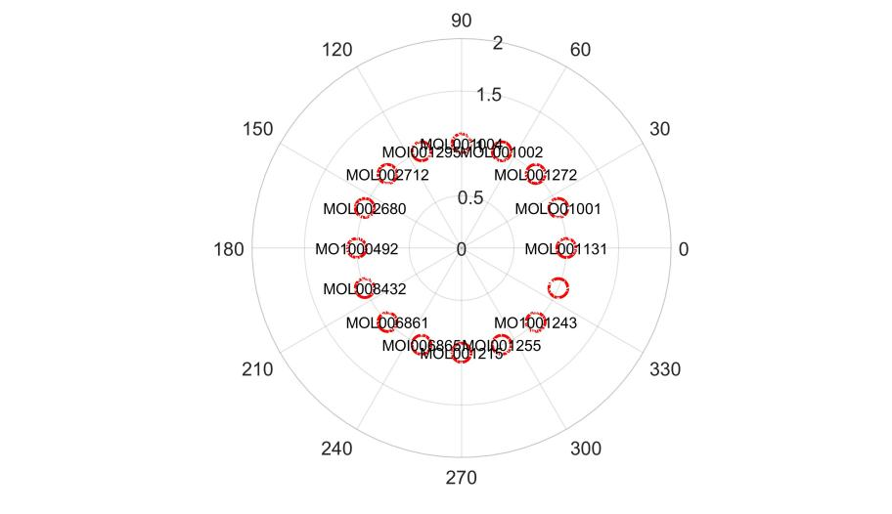

**Figure 7.** Target network diagram of the active ingredients of Qili San.

Using Cytoscape analysis technology, the pharmacodynamic substance basis and target gene analysis were conducted to establish a pharmacodynamic substance basis action network map [18], as shown in **Figure 7**. Among them, the red node represents the active ingredient of the drug and the edge line represents the correlation between the active ingredient and the target. Through bioinformatics analysis, it was found that the same effective component might simultaneously affect multiple target genes, such as anthocyanin, 6-hydroxy kaempferol and scopolin. Simultaneously, bioinformatics analysis based on the joint action of multiple effective components and targets has verified the efficacy of traditional Chinese medicine with multiple components and targets. Using the keyword “Fracture healing”, the GeneCards database, online mendelian inheritance in man (OMIM) database and therapeutic target database (TTD) were searched to obtain 2223 target genes related to fracture repair, storing them in the Excel file. Using EXCEL to compare the target genes of each effective component, 50 common target genes were identified, which were the therapeutic target genes of the effective component of Qili San. A VENN map was created. As shown in **Figure 8**.

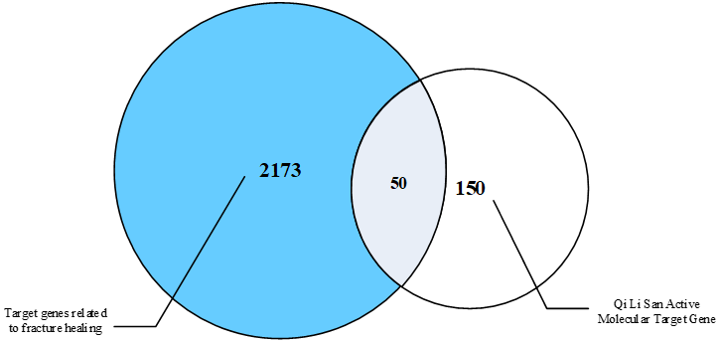

**Figure 8.** VENN map of active molecular target genes and fracture healing related target genes of Qili San.

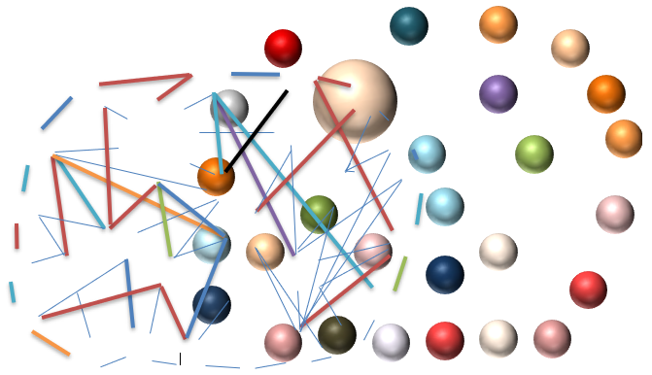

**Figure 9.** Potential targets for the treatment of fractures with Qili San.

The selected 50 common target genes were input into the STRING database to generate the producer price index (PPI) of the target genes, as shown in **Figure 9**. In this graph, there were a total of 28 nodes, with nodes representing the target gene and each edge representing the correlation between the target genes.



**Figure 10.** Bubble diagram of KEGG pathway enrichment analysis.

By inputting 50 common target genes into the David database, 77 KEGG (Kyoto Encyclopedia of Genes and Genomes) signaling pathways were ultimately obtained. The P value of each enriched pathway (*P* value below 0.01 is significant enrichment) was calculated and some biological pathways with commonality and universality were eliminated. Biological pathways which were related to or potentially important for the treatment of fractures with Qili San were extracted and their *P* values were sorted, taking the top 10 for analysis, as shown in **Figure 10**. In the figure, the size of the dots represents the total number of targets in the corresponding path and the abscissa represents the ratio of the targets enriched in the path to the total number of targets in the path.

By conducting GO (Gene Ontology) functional studies on 50 common target proteins, information on the cellular composition, biological processes and molecular functions of the target protein was obtained and a bubble map of the target protein was constructed, as shown in **Figure 11**.

In sports training, physical tissue damage caused by sudden or non sudden external forces on athletes during competition is an important factor causing bone fracture. Fracture is a disease that is classified as a trauma in traditional Chinese medicine, also known as “zhe yang”. The predecessors have written many classic works based on their rich clinical practice, such as the Han Dynasty’s “Zhe Shang Bu” and the Tang Dynasty’s “Li Shang Xu Duang Fang”. Besides, there are acupuncture and moxibustion, massage, cupping, Chinese herbal fumigation, Chinese herbal preparation and other treatments [19]. Qili San is a traditional Chinese medicine mainly composed of dragon’s blood, frankincense, myrrh, safflower, catechu, borneol, artificial musk, cinnabar and other ingredients. It is a traditional formula for treating ulcers and is used to relieve pain. At present, the mechanism of action of Qili San on traumatic fractures has been studied to some extent in modern medicine, but it still needs to be studied at the molecular level of Western medicine. Therefore, based on the previous work, this article intended to use network pharmacology methods to conduct in-depth research on the pharmacological substance basis and regulatory targets of this formula, as well as the TNF (Tumor Necrosis Factor) signaling pathway, PI3K-Akt signaling pathway and VEGF (Vascular Endothelial Growth Factor) signaling pathway, to elucidate the regulatory mechanism of this formula on multiple targets and signaling pathways. After investigation and research, it was found that in patients with ankle fractures, when using Qili San, it could significantly reduce patients’ pain, swelling and fracture healing speed, while also significantly improving ankle function and muscle strength. This was because Qili San has the effects of promoting blood circulation and resolving stasis, accelerating fracture repair and clearing inflammatory neurotransmitters.



**Figure 11.** Bubble diagram of the enrichment analysis of the core target MF (Molecular Function) in the treatment of bone injury with Qili San.

Possible side effects of Qili SAN include allergic reactions, gastrointestinal upset (such as upset stomach and diarrhea), and drug interactions. Ways to prevent these side effects include allergy testing before use to avoid allergic reactions; Use Qili SAN strictly according to the doctor’s advice, and do not increase the dose at will; Observe the body reaction after taking the drug, stop taking the drug in time and consult the doctor if discomfort occurs; When using Qili SAN, inform your doctor of all medications you are taking to avoid drug interactions.

**6. Conclusions**

The condition of sports injury has always been an important problem in physical exercise. The reason for its occurrence is closely related to the form, intensity, skill and environment of fitness exercise. It damages the motor system of the human body, as well as the blood vessels and nervous system of the body. This article applied VAS pain visual simulation scoring technology and Cytoscape analysis technology to deeply analyze the efficacy of several therapeutic drugs, which was beneficial for everyone to understand the drugs and provide better treatment methods when corresponding conditions occur. The experimental results show that PRP injection technology has a significant effect on improving the mechanical properties of the knee joint. This is mainly because the growth factors in PRP can promote cell proliferation and angiogenesis, thus enhancing the mechanical properties of the tissue. In contrast, diclofenac and indomethacin improve mechanical properties mainly through anti-inflammatory and analgesic effects, but are less effective than PRP in promoting tissue repair. Qi Li Powder promotes blood circulation and eliminates blood stasis through traditional Chinese medicine, thereby improving tissue stiffness and elasticity. These results indicate that different drugs have advantages in improving mechanical parameters, and the appropriate treatment should be selected according to the specific situation. Drug therapy is crucial for the rehabilitation of sports training injuries, promoting the rehabilitation process by reducing inflammatory reactions, alleviating pain and promoting tissue repair. Reasonable drug selection and dosage control are crucial. However, based on the limit of current scientific and technological level, the detailed mechanism of action of drug therapy for sports injury is still unclear. In the future, joint efforts are needed to make a new breakthrough in the molecular field.

**Author contributions:** Conceptualization, LY and YD; methodology, LY and YD; formal analysis, LY and YD; investigation, LY and YD; writing—original draft preparation, LY and YD; writing—review and editing, LY and YD. All authors have read and agreed to the published version of the manuscript.

**Ethical approval:** Not applicable.

**Conflict of interest:** The authors declare no conflict of interest.

**References**

1. Goddard K, Roberts CM, Byron-Daniel J, et al. Psychological factors involved in adherence to sport injury rehabilitation: a systematic review. International Review of Sport and Exercise Psychology. 2020; 14(1): 51-73. doi: 10.1080/1750984x.2020.1744179
2. Gennarelli SM, Brown SM, Mulcahey MK. Psychosocial interventions help facilitate recovery following musculoskeletal sports injuries: a systematic review. The Physician and Sportsmedicine. 2020; 48(4): 370-377. doi: 10.1080/00913847.2020.1744486
3. Xu S, Zeng L. Rehabilitation Path of Knee Ligament Proprioception Loss Caused by Sports Injury. Clinical research. 2020; 61(3): 1258-1267.
4. Malmgaard-Clausen NM, Jørgensen OH, Høffner R, et al. No Additive Clinical or Physiological Effects of Short-term Anti-inflammatory Treatment to Physical Rehabilitation in the Early Phase of Human Achilles Tendinopathy: A Randomized Controlled Trial. The American Journal of Sports Medicine. 2021; 49(7): 1711-1720. doi: 10.1177/0363546521991903
5. Wiffen PJ, Xia J. Systematic review of topical diclofenac for the treatment of acute and chronic musculoskeletal pain. Current Medical Research and Opinion. 2020; 36(4): 637-650. doi: 10.1080/03007995.2020.1716703
6. Haider MN, Herget L, Zafonte RD, et al. Rehabilitation of Sport-Related Concussion. Clinics in Sports Medicine. 2021; 40(1): 93-109. doi: 10.1016/j.csm.2020.08.003
7. Sánchez Díaz M, Martín-Castellanos A, Fernández-Elías VE, et al. Effects of Polyphenol Consumption on Recovery in Team Sport Athletes of Both Sexes: A Systematic Review. Nutrients. 2022; 14(19): 4085. doi: 10.3390/nu14194085
8. Gentile P, Garcovich S. Systematic Review—The Potential Implications of Different Platelet-Rich Plasma (PRP) Concentrations in Regenerative Medicine for Tissue Repair. International Journal of Molecular Sciences. 2020; 21(16): 5702. doi: 10.3390/ijms21165702
9. Huang H, Luo M, Liang H, et al. Meta-analysis Comparing Celecoxib with Diclofenac Sodium in Patients with Knee Osteoarthritis. Pain Medicine. 2020; 22(2): 352-362. doi: 10.1093/pm/pnaa230
10. Fogel EL, Lehman GA, Tarnasky PC, et al. Rectal indometacin dose escalation for prevention of pancreatitis after endoscopic retrograde cholangiopancreatography in high-risk patients: a double-blind, randomised controlled trial. The Lancet Gastroenterology & Hepatology.2020; 5(2): 132-141. doi:10.1016/S2468-1253(19)30337-1
11. Alves R, Grimalt R. A Review of Platelet-Rich Plasma: History, Biology, Mechanism of Action, and Classification. Skin Appendage Disorders. 2017; 4(1): 18-24. doi: 10.1159/000477353
12. Everts PA, van Erp A, DeSimone A, et al. Platelet Rich Plasma in Orthopedic Surgical Medicine. Platelets. 2021; 32(2): 163-174. doi: 10.1080/09537104.2020.1869717
13. Sarı S, Aydın ON, Turan Y, et al. Which one is more effective for the clinical treatment of chronic pain in knee osteoarthritis: radiofrequency neurotomy of the genicular nerves or intra‐articular injection? International Journal of Rheumatic Diseases. 2016; 21(10): 1772-1778. doi: 10.1111/1756-185x.12925
14. Chang NJ, Erdenekhuyag Y, Chou PH, et al. Therapeutic Effects of the Addition of Platelet-Rich Plasma to Bioimplants and Early Rehabilitation Exercise on Articular Cartilage Repair. The American Journal of Sports Medicine. 2018; 46(9): 2232-2241. doi: 10.1177/0363546518780955
15. Lundberg TR, Howatson G. Analgesic and anti‐inflammatory drugs in sports: Implications for exercise performance and training adaptations. Scandinavian Journal of Medicine & Science in Sports. 2018; 28(11): 2252-2262. doi: 10.1111/sms.13275
16. Jiang M, Li F,Li F, et al. Experimental study on the anti-inflammatory effect of qilisan with and without cinnabar. Shandong Chemical Industry 2018; 47(4): 25-26.
17. Liu Z, Xie L, Jin Y,et al. Quantitative microscopic study of saffron in Qilisan. Journal of Pharmaceutical Research. 2020; 39(7): 385-387.
18. Yao X, Zhang X, Ma S, et al. Study on the Mechanism of Sanqi in the Treatment of Disseminated Intravascular Coagulation-Based on Network Pharmacology and Molecular Docking Technology. Letters in Drug Design & Discovery. 2023; 20(7): 881-893. doi: 10.2174/1570180819666220512110520
19. Shan S. A review of the modalities and application of Chinese medicine in the treatment of delayed fracture healing. Chinese Journal of Convalescent Medicine. 2018; 27(3): 252-253.